*Spiral Review for Unit 5: Polygons & Quadrilaterals*

/Users/Rasa/Desktop/Screen Shot 2016-11-27 at 9.30.38 PM.png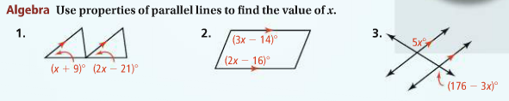

/Users/Rasa/Desktop/Screen Shot 2016-11-27 at 9.31.13 PM.png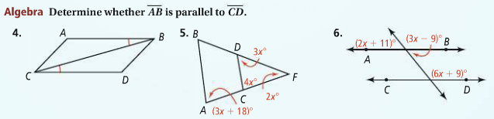

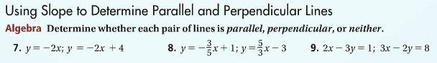

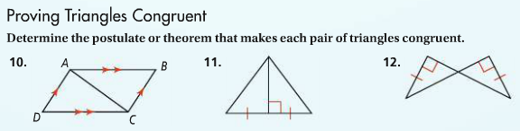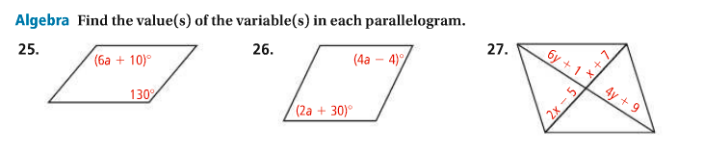

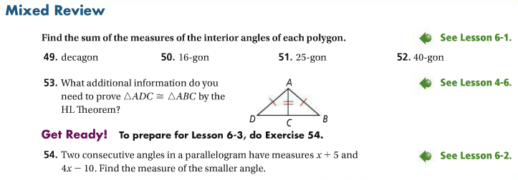





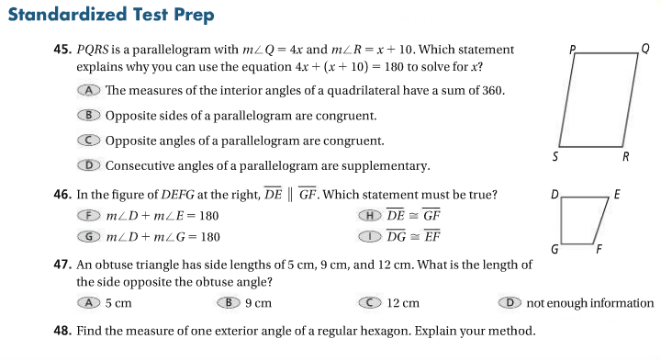

**5.3 Properties of Parallelograms HW**

*Mild: You will get a 8/10 for completing only this section*

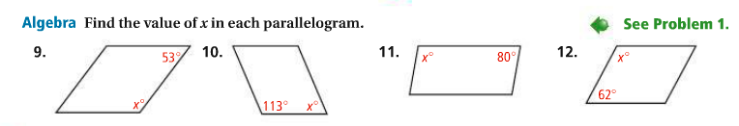

13.   






*Medium: You will get a 9/10 for completing this section in addition to the Mild*

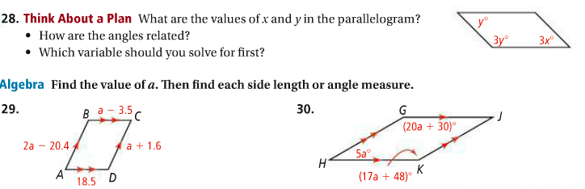



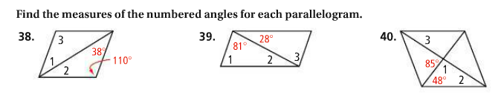

Screen%20Shot%202017-11-28%20at%2010.09.21%20PM.png

*Spicy: You will get a 10/10 for completing this section in addition to the Mild*

1.

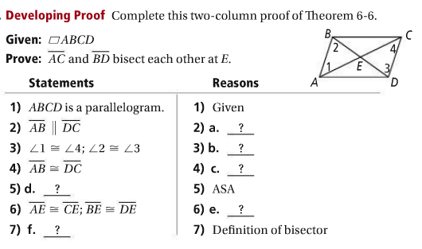

2.

